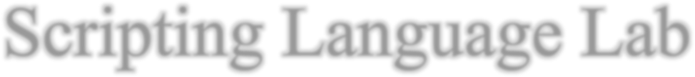

Scripting Language Lab



Lab-10 Assignment

NAME: Nishtha Upadhyay

REG NO. 201900182

Github Link:

Q. Create a todo application having following components

1. ***Todo List Component - Display todo in list format***
2. ***Todo Details Component - Display todo in table format***
3. ***app root (main) component***
4. ***Create a service (TodoService) and share data amongst Todo List & Todo Details Components***

# Creating components:

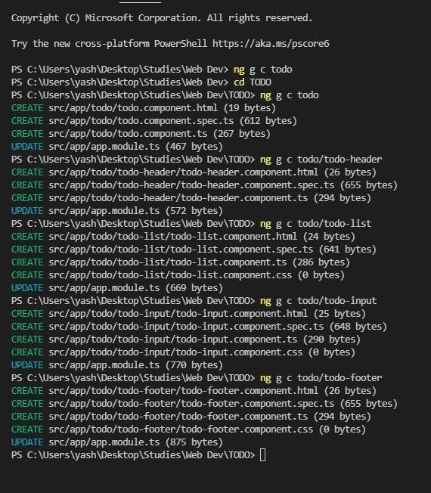

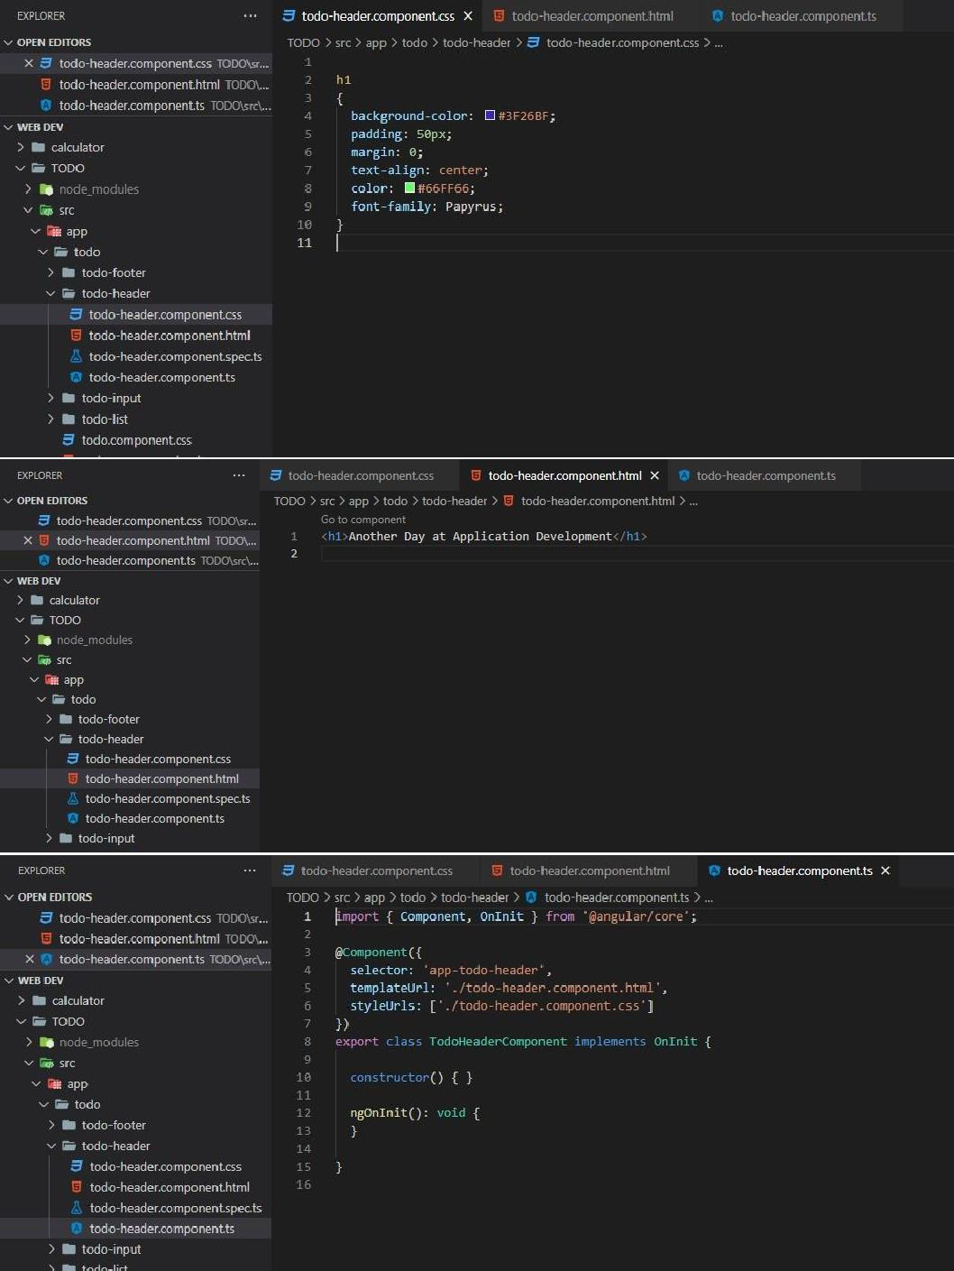

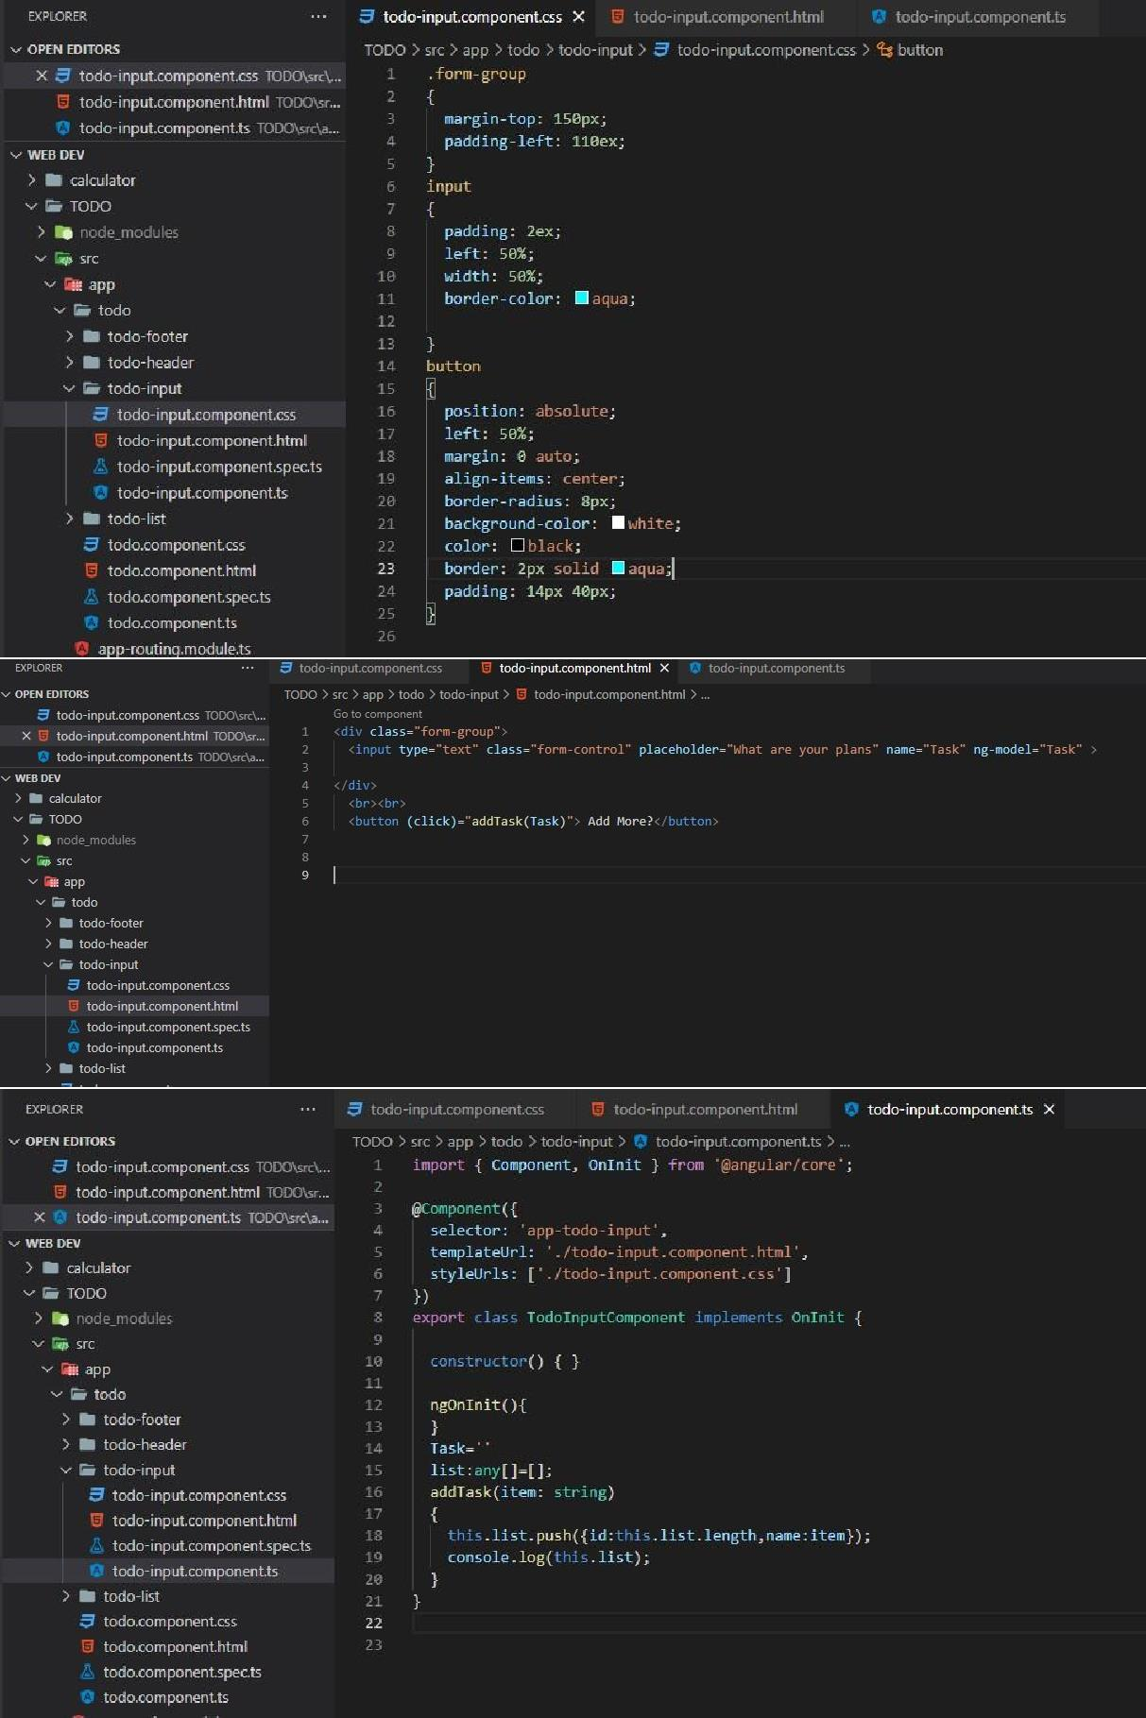

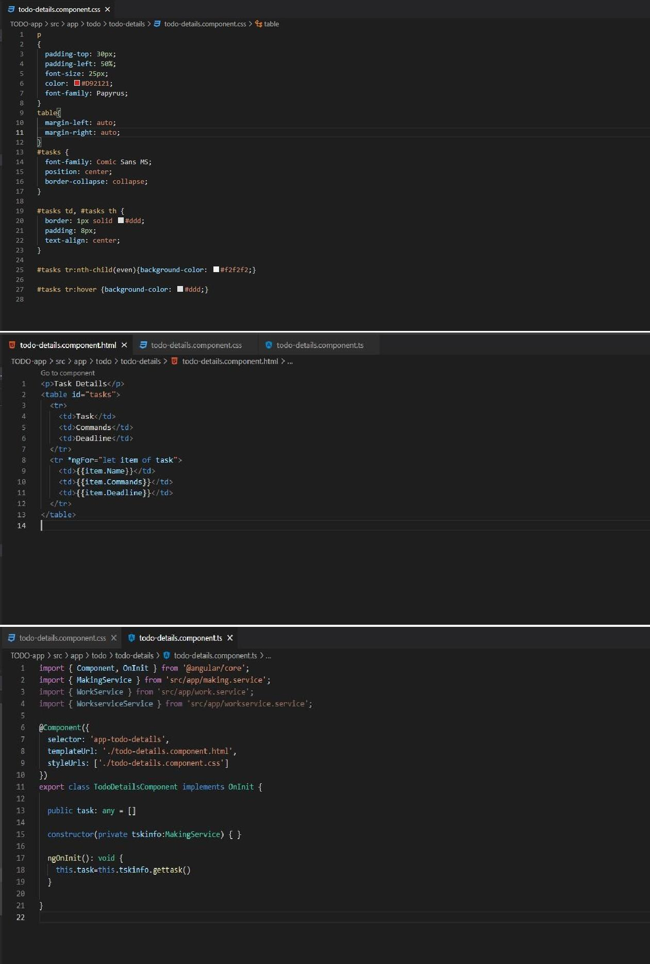

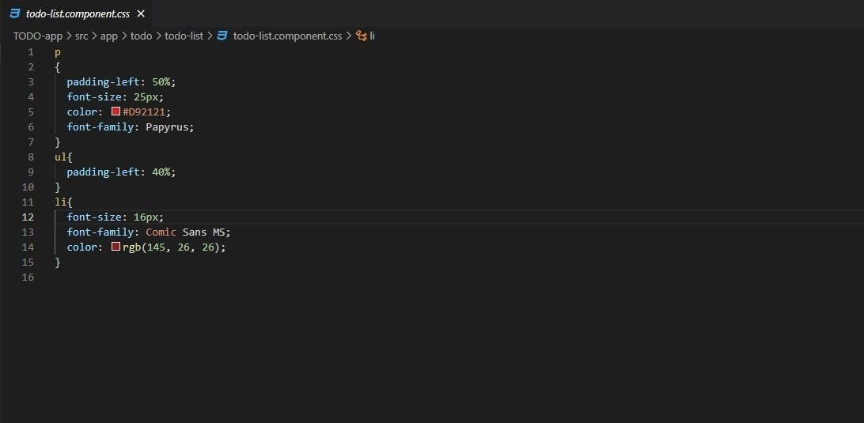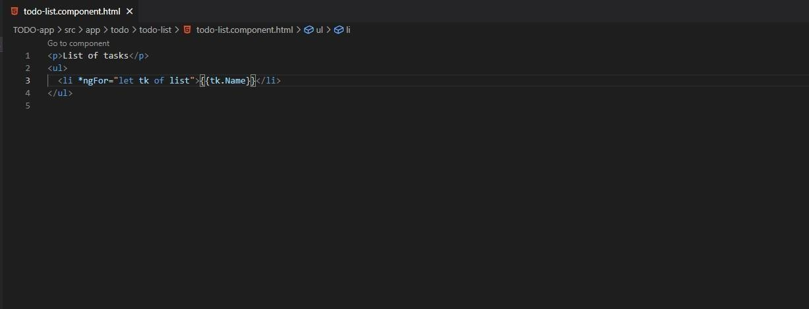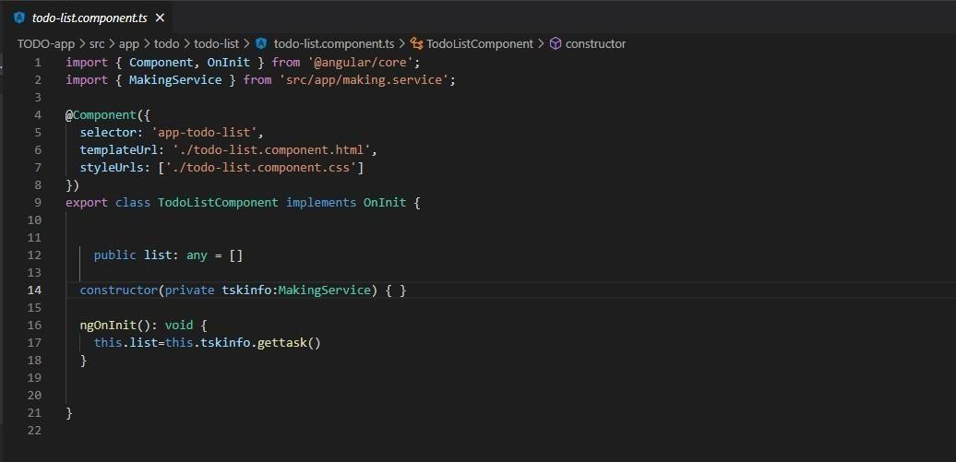

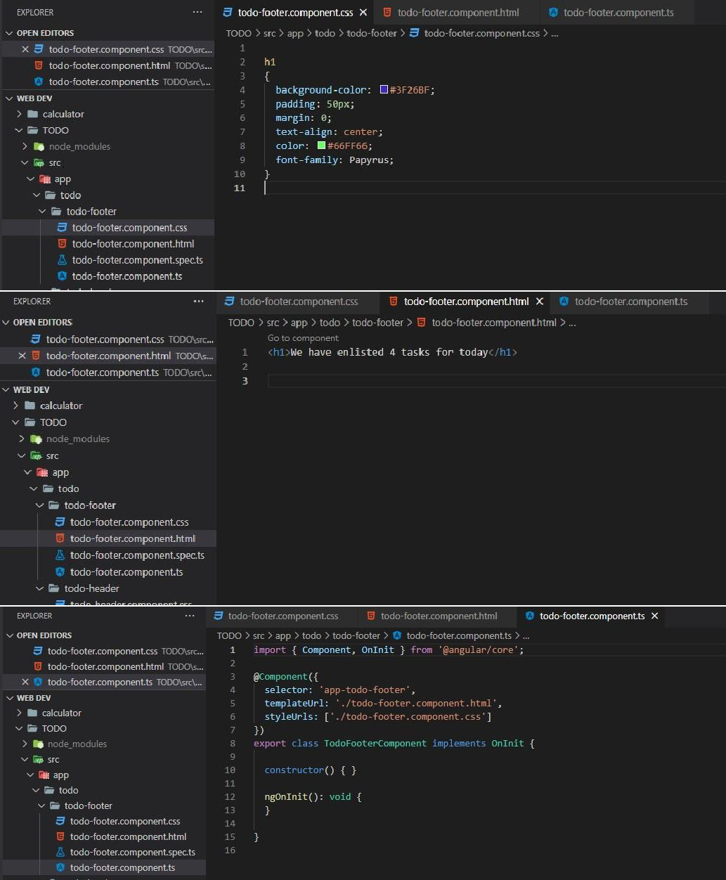

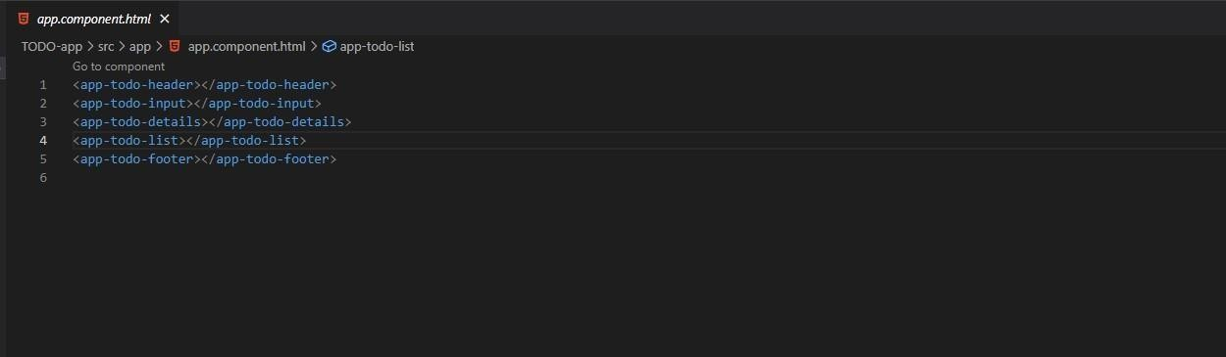

***App Component module file:***

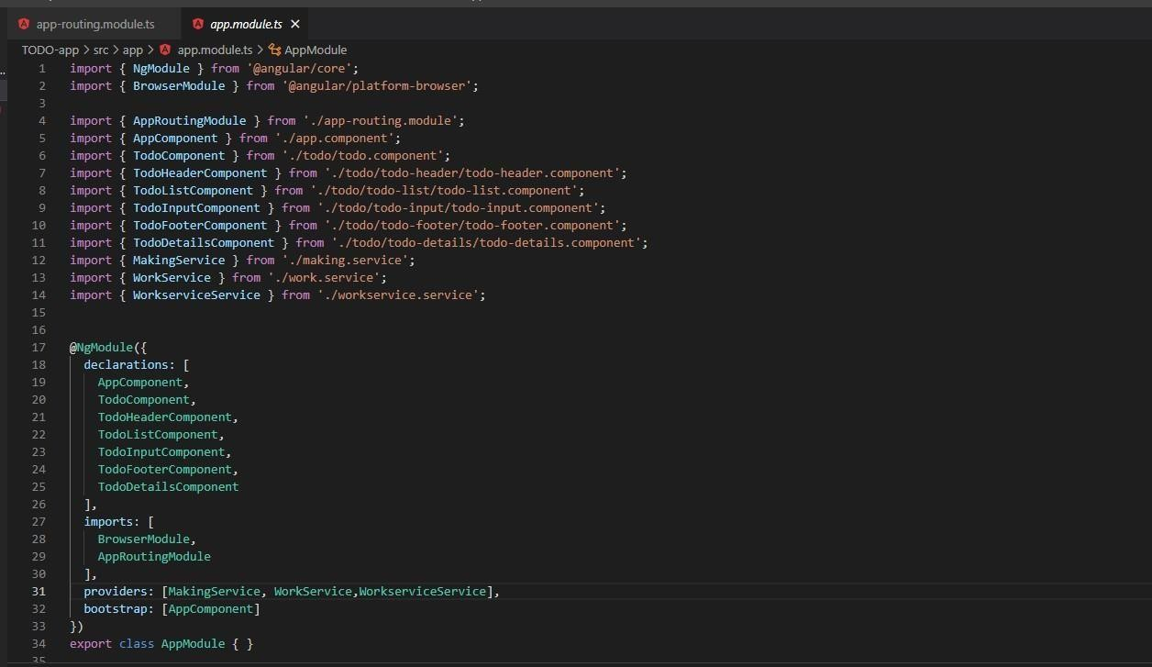

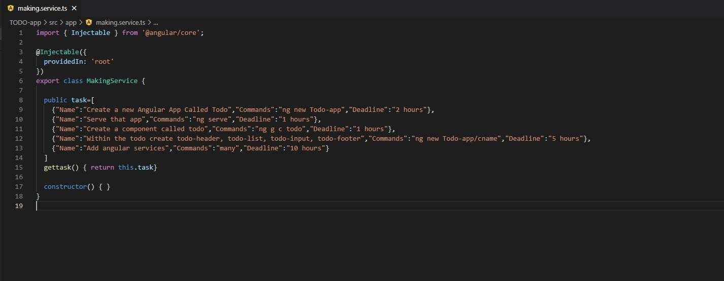

***GITHUB repository link: https://github.com/deoman17/lab10_***

***Final Output:***

